TC-CMS-031
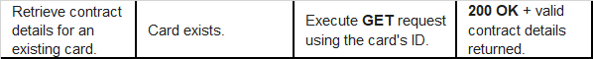
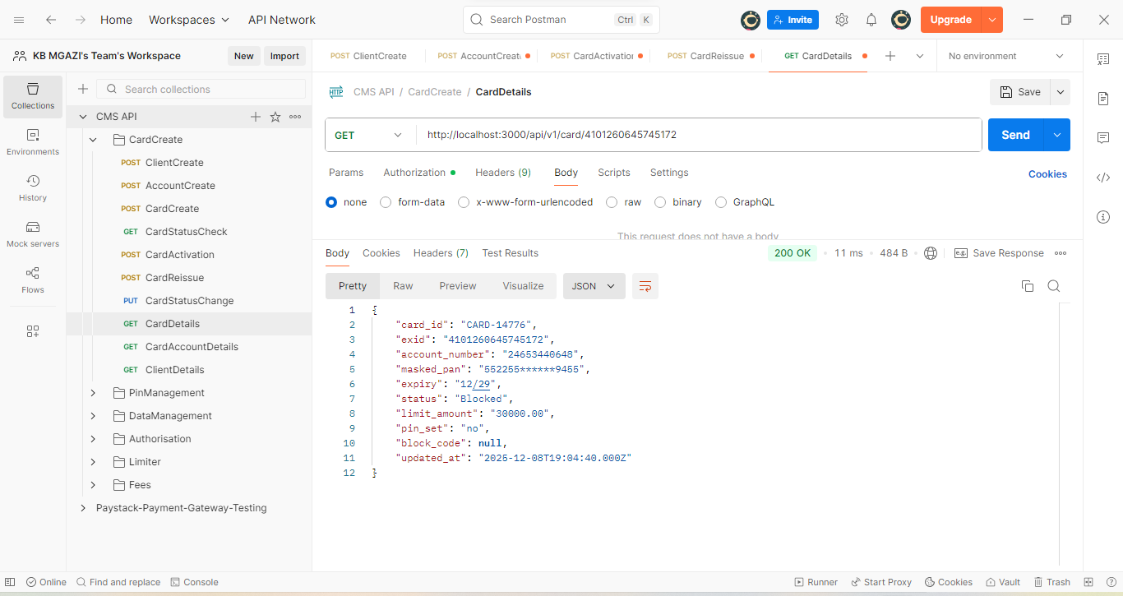
Response:
{
"card_id": "CARD-14776",
"exid": "4101260645745172",
"account_number": "24653440648",
"masked_pan": "552255******9455",
"expiry": "12/29",
"status": "Blocked",
"limit_amount": "30000.00",
"pin_set": "no",
"block_code": null,
"updated_at": "2025-12-08T19:04:40.000Z"
}

